Useful Tech Tools

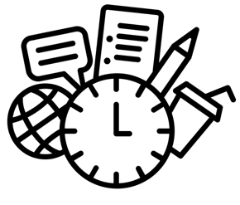 | Adobe Scan  Download the free Adobe Scan mobile app to scan anything into a PDF using your mobile device. Scan documents, whiteboards, forms, receipts and more.
CamScanner
This is an intelligent document management app for your phone and tablet that uses your device camera to take pictures of book pages and convert them to PDFs. Sign up with your university email and get some extra storage. Pretty easy to use, quality seems acceptable, and links to your cloud storage.
Kanopy
On-demand streaming video platform service. Free.
Slack
Chatroom for your whole team. Replaces emails with a chatroom. Mac OS.
TurnItIn
Internet-based plagiarism prevention system. To learn more, click here.
Zoom
Platform used for video and web conferences. Can be downloaded to computer or smart phone or you can dial in to join conference.
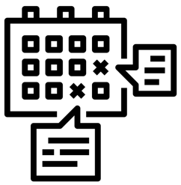 | Calendly  This platform integrates your calendars into one place to help schedule meetings with students and staff members. 30-Day free trial.
Google Calendar
Time management and scheduling calendar service. Students and staff can create events and add reminders. Free.
Doodle
User friendly smart planner to help you schedule meetings. Create a poll to figure out what days’ work best. 14-Day free trial.

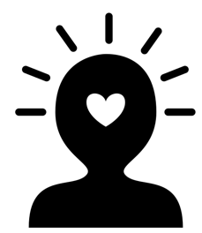 | Headspace  Free mediation app for apple and android  UCLA CAPS Live Health Online  See a licensed therapist or psychologist through phone, tablet, or computer. For more useful apps, scroll to the bottom of the page.
UCLA Mindful App
For a quick stress reliever, UCLA’s Mindful Awareness Research Center offers free guided meditations in English and Spanish.
UCLA MindWell
Better Sleep info sheet.

Tips for Instructors and Students moving to online learning
- Collective Wisdom

- Training for Change

- Resources for Teaching Remotely: A Community Space

Resource for UCLA Faculty and Instructors to learn the basics of teaching remotely. Topics range from communicating with instructors, grading and assessments, groupwork and interaction, etc.

- Center for the Advancement of Teaching

Resources for Teaching Assistants to help navigate the transition to online teaching.
Zoom How To:

Virtual Background
Zoom feature that might appeal to those who are filming from an odd corner of our homes: you can enable a virtual background image. You need a "green screen" behind you, but otherwise it looks pretty easy.
Waiting Room
When you are doing virtual office hours, you can set your system up so that students are put in a waiting room until you admit them to the session individually.

